26.22: From the circuit in Fig. 26.42, we use Kirchhoff’s Rules to find the currents,
to the left through the 10 V battery, to the right through 5 V battery, and 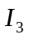to the right through the 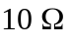 resistor:
Upper loop:
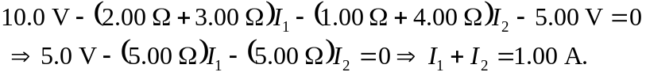
Lower loop:
Along with 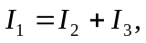 we can solve for the three currents and find:
b)

